**Three-Phase Full Wave Rectifier Schematic**

For getting DC voltage from the AC voltage, three phase full wave diode rectifier is used. For this purpose, 2 x KPBC5010 Bridge Diode are used. After that, for the decrease a ripple at the DC output, 1000 µF capacitor is used. With this circuit, DC voltage is got from the AC voltage source and this DC voltage’s outputs directly connected to Vcc of the controller, buck converter and gate driver, and lastly ground is connected to common ground.

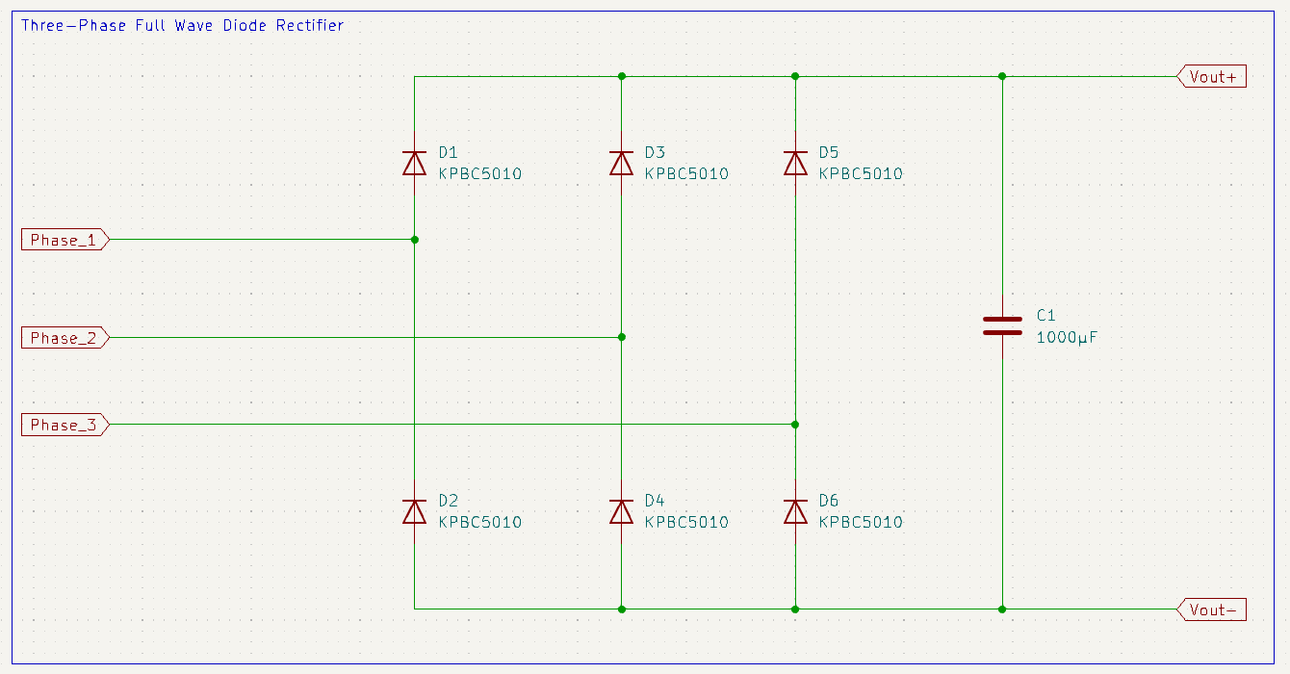

*Figure X. Three Phase Full Wave Diode Rectifier Schematic*

**Controller Schematic**

For PWM generating, TL494 integrated circuit is used. It has different operation modes. With this controller, CC / CV operation modes are provided. For this purpose, error amplifier pins are used. Moreover, TL494 contains a 5 V voltage regulator itself. 5 V output voltage is supplied at reference pin. This pin is used for adjusting PWM output according to adjusting voltages at pins 2 and 15 are used. Then pins 1 and 16 pins get feedback from the buck converter part. Frequency of the PWM generator adjusted with pins 5 and 6. Connected resistor and capacitor’s values adjust the frequency. Then, TL494 can work at the voltages between 7 and 40. It is big advantage for this project because system operates between 19 and 33 V. So, TL494 can be connected to input voltage directly, so extra voltage regulator is not needed.

metin, diyagram, plan, şematik içeren bir resim

Açıklama otomatik olarak oluşturuldu

*Figure X. Pin Connections of TL494*

From the information and application notes of this controller at the datasheet is got reference. Then, design of the controller was started. Firstly, for the schematics, KiCAD will be used.

Firstly, circuit diagram of the controller can be seen in Figure X.

diyagram, plan, teknik çizim, şematik içeren bir resim

Açıklama otomatik olarak oluşturuldu

*Figure X. Controller Schematic Design*

8 and 11 pins are directly connected to Vcc, which is input voltage of the buck converter. Internal PNP transistors’ collector pins are directly connected to input voltage with these connections. Then, 9 and 10 pins are again the collector pins of the internal PNP transistors. PWM signals are generated at these pins, and they will be connected to MOSFET driver circuit with serial 10 Ω resistor.

After that, for the adjusting the frequency of the PWM signal, pins 5 and 6 are used. Frequency value of the PWM signal formula is:

$$fpwm = 1/\left(RT * CT\right)= 1/ [({10}^{-9}) * 4 K] = 25 kHz$$

Then capacitor and resistor are grounded.

After these connections, voltage dividers are applied on the reference voltage pin, 14. 1K and 3.9K are used for the first voltage divider. With this voltage divider $5 V * (1K / 4K) = 1 V$ is got. Then this signal is connected to error amplifier 2’s inverting input, 15. Then, this error amplifier’s non-inverting pin is directly connected to shunt resistor which is serial connected directly to output of load and then goes to ground. These connections will be provided more detailed at other schematics. Then another voltage divider applied on the reference voltage pin. 2 x 10K Ω resistors are connected serial to the ground. Then obtained voltage level is connected serial with 560 Ω to error amplifier 1’s inverting input. From this connection, feedback pin is connected to this connection by 50K serially. Lastly, pins 4, 13 and 7 are grounded.

With this controller design, MOSFET is switched depending on input voltage and output voltage. TL494, keeps the output current constant at 10 A and duty cycle of the PWM signal is changing continuously depending on the feedback’s from the shunt resistor. For the project requirements, input voltage varies between 19 and 33 V and battery voltage level can be change between 11 V and 14 V according to State of Charge. Moreover, battery has internal resistance, so in summary, TL494 generate PWM signal according to these information. Simulation results will be provided in Simulation Results part.

**Gate Driver Schematic**

After getting the PWM signal from TL494, gate driver circuit must be used for switching the Power MOSFET IRF540. With the MOSFET driver circuit, gate signal’s current will be amplified and with gate driver resistor, switching time between the ON / OFF stages is decreased. With this operation, thermal and power efficiency is increased. Also, the oscillation in the opening situations is decreased, so total EMI which is harmful for the operation of device is reduced.

Gate Driver circuit is implemented with 2 power BJT’s. NPN BD139 and PNP BD140 transistors are used. Also, resistors 2 x 1K Ω, and 56 Ω are used.

metin, diyagram, çizgi, ekran görüntüsü içeren bir resim

Açıklama otomatik olarak oluşturuldu

*Figure X. Gate Driver Circuit Schematic*

So, implemented gate driver can be seen in Figure X. With this gate driver, oscillations which happened when MOSFET is opening, are reduced and total EMI on the design is reduced and gate signal is amplified. MOSFET can be opened more easily.

**Buck Converter Design**

According to calculations of the converter, buck converter design is implemented. IRF540N, Schottky Diode MBR20100CT, 50 µH inductor, 470 µF capacitor, 0.1 shunt resistor and 2 resistors are used. From the buck converter, feedbacks for TL494 are provided. For the current adjusting, 0.1 shunt resistor used and with this implementation, adjusted current is 1 / 0.1 = 10 A. Then, for CC / CV topology, voltage divider is used and signal from this divider connected to pin 1. Stone resistor with 10 W is used for the sensing current because total power on this resistor is 102 * 0.1 = 10 W.

metin, diyagram, çizgi, öykü gelişim çizgisi; kumpas; grafiğini çıkarma içeren bir resim

Açıklama otomatik olarak oluşturuldu

*Figure X. Buck Converter Schematic*

**Simulation Results**

For the simulations, proteus simulation program is used. This program was preferred because it contains most of the components used in the circuit in its library and the simulation results are similar to real-life applications.

Full circuit schematic of the system is implemented at the proteus program. Firstly, 3-phase diode rectifier circuit is implemented at the input stage. With 1000 µF, input voltage ripple is decreased. Then from this input voltage TL494 controller is worked. After that controller circuit is designed. Then MOSFET Gate Driver circuit is implemented at output of the PWM signal of the TL494. Lastly buck converter is implemented.

çizgi, diyagram, paralel, öykü gelişim çizgisi; kumpas; grafiğini çıkarma içeren bir resim

Açıklama otomatik olarak oluşturuldu

*Figure X. Full Circuit Schematic of the Battery Charger*

After the simulation setup is constructed, simulation is run.

Firstly, input stage is obtained. Three-phase voltage supply is connected at the input voltage and three-phase diode rectifier is used for the getting DC voltage from the input. From the simulation results, DC voltage with small ripple is achieved.

elektronik donanım, ekran görüntüsü, elektronik mühendisliği, devre içeren bir resim

Açıklama otomatik olarak oluşturuldu

F*igure X. Digital Oscilloscope Screen for Input Voltage vs Output Voltage at Three-Phase Diode Rectifier Out*

For this simulation, Three-Phase Voltage source with 40 V amplitude is used and average output voltage is obtained as 37.25 V and ripple is 38.5 – 36.5 / 37.25 = 5.37%.

Then, outputs of the TL494 controller are obtained. From the theoretical calculations of the controller, expected duty cycle of PWM signal is adjusted to getting 10 A at the output stage. For this purpose, pin 15 and 16 are used as discussed. With the voltage divider at the reference voltage pin, 1 V signal is connected to pin 15. Then, pin 16 is directly connected at the resistor which is connected between ground and load. After these operations, PWM signal is obtained at the pins 9 and 10 after the connections. Resulted PWM signal can be seen in Figure X. Resulted PWM Signal’s specifications are listed: period = 0.05 ms so frequency is 20 kHz and duty cycle is 0.03 ms / 0.05 ms = 60%.

ekran görüntüsü, kare, dikdörtgen, çizgi içeren bir resim

Açıklama otomatik olarak oluşturuldu

Figure X. Generated PWM Signal on the PİNS 9 and 10

After getting the PWM signal, gate driver circuit is connected with 10 Ω resistor to PWM signal pins. After that gate signal of the MOSFET is obtained.

ekran görüntüsü, kare içeren bir resim

Açıklama otomatik olarak oluşturuldu

Figure X. MOSFET Gate Signal

Resulted signal has no oscillation. So, expected oscillations when the MOSFET’s switching case are reduced.

After this observations, MOSFET source voltage waveform is obtained.

elektronik donanım, ekran görüntüsü, elektronik mühendisliği, devre içeren bir resim

Açıklama otomatik olarak oluşturuldu

Figure X. MOSFET Source Voltage Waveform

From this voltage waveform, it can be easily obtained that switching is happened successfully.

Then current waveform of the inductor is obtained.

ekran görüntüsü, yeşil, renklilik içeren bir resim

Açıklama otomatik olarak oluşturuldu

Figure X. Current Waveform of the Inductor

From the current waveform of the inductor, it can be understood that charger operating at Continuous Conduction Mode and current goes 6.5 A to 13.5 A. Ripple at the inductor current is very high. However, with the real-life application and at the laboratory environment, inductor is designed with value around 50 µH and this inductor used in simulations. In conclusion, 10 A average output current is obtained.

Last operations for these simulations is changing input voltage level and checking the 10 A output current. At the second test, input voltage amplitude increased to 60 V. Then same output current is obtained.

ekran görüntüsü, çizgi, kalıp, desen, düzen, kare içeren bir resim

Açıklama otomatik olarak oluşturuldu

Figure X. Inductor Current and PWM signal at the Second Stage

From the increased voltage level simulations, inductor current ripple increase, however, average current value is same. Then, when the PWM signal is obtained, frequency doesn’t change, duty cycle decreased to 0.025 ms / 0.057 ms = 43.86%.

In conclusion, general design of the battery charger works well, however it’s ripple is so high. For the high battery voltage levels, duty cycle increase according to battery voltage level and keeps current constant at 10 A value.